Cropping a photo
Load image file
Choose the Rectangle Select Tool
Drag a rectangle to mark required area of image. Fine tune the selected rectangle by dragging the “handles” along the rectangle edges.
Crop to the required area. Image | Crop to Selection
Export the cropped image to a new file.

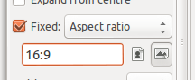
Tip: You can set the rectangle to a particular proportion by setting a Fixed Aspect Ratio in the Tool options.
Useful ratios are
4:3 - traditional TV and the VGA/XGA family of monitors)
8:5 - the WXGA family of widescreen monitors (aka 16:10)
16:9 - widescreen TV
Tip: You can also make the tool select an exact size by setting a Fixed Size (in pixels) instead of a fixed ratio.
Tip: Remember to untick the Fixed option to restore the tool to its normal function.

Resizing an image
Load image file
Scale the image to the required size. Image | Scale Image
Enter the new required Width (or Height) and click the Scale button.
Export the resized image to a new file.

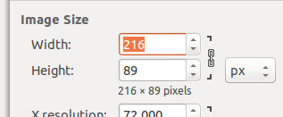
Tip: Normally the aspect ratio is fixed, so changing the width alters the height proportionally (and vice versa). If you actually want to distort the image, click the link image to the right of these settings and enter both new height and width.
Lock/unlock
fixed ratio

Correcting a photo that is not level
Load image file
Choose the Rotate Tool
Click on the image and either drag the image or use the controls in the dialog box to rotate the image as required. Click the Rotate button when satisfied with settings.
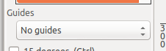
Crop the photo to remove the transparent edges.

Tip: Various guides are available to assist visually but you may find it easier to switch Guides off in the Tool Options.

Rotate an image 90°
Load image file
Rotate 90° left or right as required. Image | Transform | Rotate 90° clockwise
or anti-clockwise
Export the corrected image to a new file.

Adjusting image colours, contrast and brightness
Load image file
Open the Colour Adjustment dialog. Colours | Levels…
The first step is to see if GIMP can automatically enhance the image.
Click the Auto button.
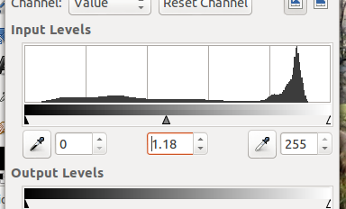
Gamma level
adjustment
Useful improvements often come from adjusting the Gamma level using either the central slider or the numeric control.

Export the corrected image to a new file.

Tip: If results are not an improvement click the Reset button and try other settings.
Note: Although the image is updated as you make changes, this is only a preview. Changes are not committed until you click the OK button in the dialog.

Drawing a straight line
Open a new blank image at least 640 x 480 px. File | New...
In the dialog either set the image size in pixels as required, or choose a preset size from a template.
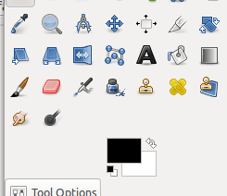
Colour Picker
Set the foreground colour by either clicking the Foreground Colour or using the Colour Picker tool.
Foreground
Colour

Choose the pencil tool and make the following tool settings:
Mode: Normal
Opacity 100%
Brush: Round with hard edge
Size: Between 1 and 5 for a fine line
Click once on the drawing area to mark the start of the line.
Move to where you want the line to end and hold the Shift key down
Still holding the Shift key, move the pointer if needed to correctly position the line.
When happy, left-click to complete the line
To continue the line, move the pointer to the new end point, hold down Shift, and left-click when the line is in the right place.

Tip: To draw an accurate horizontal or vertical line, or at 15° intervals, press and hold down the Control key after pressing the Shift key.

Drawing a rectangle or ellipse
Open a new blank image
Set the foreground colour to the colour you want to use for the line.
Choose either the Rectangle Select or Ellipse Select tool.
Draw the shape you want. Adjust if necessary using the resize handles.
When ready, set line drawing options in the Stroke Selection dialog.
Edit | Stroke Selection...
Default line
settings
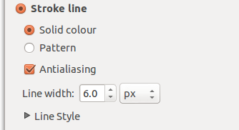
For a solid line, choose
Solid colour
Tick Antialiasing
Choose line width
Click on Stroke to draw the line and close the dialog.

Tip: To draw a square or circle, set the aspect ratio to 1:1 in the Tool Options for the selection tool you are using.
Tip: To draw a dotted line, expand the Line Style part of the Stroke Selection dialog box and choose one of the Dash preset styles.
Tip: To draw a filled circle, draw the selection and choose Edit | Fill with FG colour

Adding a Drop Shadow
Open a new blank image
Draw a filled ellipse
With the ellipse still selected, add the Drop Shadow effect.
Filters | Light and Shadow | Drop Shadow... and adjust settings as required in the dialog.

Tip: The drop shadow is added as a separate layer. You may want to merge this with the drawing layer. Right-click the drop shadow layer in the layers panel and choose Merge Down.

Create image with faded edges
Open the source image
Choose either the Rectangle or Ellipse selection tool.
In the tool options, tick Feather Edges and set a pixel distance of typically 15 to 30 px.
Select the required area.
Make a copy of the selected area and paste as a new image.
Edit | Copy
Edit | Paste as | New Image

Fade image to transparent
Load image
Add a white layer mask. Layer | Mask | Add Layer Mask... | White (Full Opacity)
Use the Blend tool and set tool option Gradient to FG to Transparent. Start from part you want totally transparent and drag to where fade should begin. (Shape set to Linear is usually most useful but try other options.)

Tip: Hold the control key while dragging to constrain direction of fade to vertical, horizontal or 15° angle steps
Note: Some image files, typically GIF files, may need to be converted to use the full RGB colourspace before fades will work. Image | Mode | RGB
Note: Not all graphics file formats support transparency, so export to .png or .jpeg to be safe.

Fade image to white (or other colour)
Start by fading image to transparent (see above).
Add a new layer. Layer | New Layer... | White
Move the layer to the bottom of the drawing stack. Layer | Stack | Layer to Bottom

To fade to a colour, first set the foreground colour to the required colour.
Then add a new layer of this colour. Layer | New Layer... | Foreground Colour
and move layer to the bottom. Layer | Stack | Layer to Bottom

